Winchcombe Parochial Church Council

Minutes of the Meeting held on 16th May 2022 at 7.30 pm

By Zoom
Present: Geof Adlington (GA) (Treasurer), Abbie Andrews (AA), Simon Andrews (SA) (Chair), Elizabeth Atkinson (EA), Susan Fleck (SF), Felicity King (FK), Judith Skinner (JS), Rob Stone (RS), Trevor Upton (TU) (Methodist Observer), Liz Watson (LW) (Secretary), Lynne Banks (for items 1, 2, 3, 4 and 18) (LB).
Apologies: Rosemary Hancock (RH), Sue Fleck (SF), Cathryn Wilcox (CW)

 |  | Action
1 | Welcome and Opening Prayer: JS said the opening prayers.
2 | Apologies for Absence  As stated above.
3 | Matters Arising from Minutes of Last Meeting  - RS confirmed that the Families & Childrens’ Worker Job Description has been amended to include reference to families in the “Candidate Specification”. A version of the job description has been agreed by the working group and is now awaiting confirmation from the Diocese. A meeting has been arranged between Diocesan representatives and Working Group members on 26th May, to take the project forward.  - Magazine has given point of contact for Winchcombe Churches Together (WCT).  - Gas supplier review: the relationship with Gazprom is under review.  - Revd Rachel Forrest’s leaving party has been agreed as bring and share lunch. A Parish present has been agreed and Penny Kain is making a personalised chasuble, and contributions are still welcome.
4 | Consideration of the Agenda  - The agenda business was briefly reviewed and no further items were added.
5 | Correspondence, News and Notices  - The Secretary reported that the APCM papers have been circulated and that electoral roll notices have been posted in churches. Any other correspondence is referred to elsewhere on the agenda.
6 | Coronavirus: Parish Activity Update: SA observed:  - The policies and advised practices respecting coronavirus are under continual review by the Leadership Group.  - With the Covid spike reducing, the St Peter’s South pews have had their barriers removed. Similar arrangements have been delegated to Deputy Churchwardens.  - The PCC further noted that new Diocesan guidance has been issued regarding Holy Communion that will allow individuals to take wine direct from the chalice as before. However, as it is recognised that not everyone is ready to return to this practice, a delivery system is being reviewed which will allow the taking of the wine from the chalice for those who are happy to do so, but will also allow the intinction (dipping of wafer into the wine) for those who are more cautious. This will be explained and tried for the first time at St Peter's 10.30am service on Sun 26 Jun. If this pilot is successful, it is expected that it will be used within all the Parish's churches. The PCC was supportive of this proposal.
7 | Staff and Appointments (SA).  - PCC Treasurer for 2022. An individual has been identified who may be interested in taking on the role of PCC Treasurer. Discussions have taken place with the current Treasurer (GA) to review what is involved with the role and further discussions will take place with the goal of securing a new Treasurer. No further action will be taken by SA regarding creating a fuller job description than the already created task list.  - Abbeyfields School Foundation Governor. Lynne Banks’ extension and Sara Collins’ selection to replace Tony Mason has been finalised. Tony Mason stands down with effect 17 May and the PCC thanks him for his work in that role.  - PCC Members Extension. With annual voting for PCC membership due at the APCM, the current PCC have been asked to stay on until at least next year’s APCM to cover the Vacancy period and allow stability in a new priest-in-charge’s first few months when selected. Any PCC member not wishing to continue for a further year should inform the Chair directly. Afternote: Rob Davies has informed SA that he will be standing down at this next APCM but will continue to oversee the development and lead for the Son-et-Lumière and Christmas Fair events in 2022. SA has thanked him separately for his work with the PCC. | All
8 | - Finance:  - 2022 Accounts to Date (GA)  The income and expenditure report for year-to-date was presented (see spreadsheets presented as Attachment 1), but attention was drawn to the way in which the figures are mid-quarter and therefore not very useful. With regard to income it is mostly as expected and budgeted with the following qualifications. Planned giving and associated gift aid relief is 7% less than budgeted for even allowing for the fact that we have a small gifts gift aid claim due. The collections at church services are still hugely disappointing and a cause for concern. We are in the process of reclaiming over £1000 of VAT under the LPWS provisions relating to invoices for lead pipe and roof repairs at St Marys, Sudeley. With regard to expenditure there is nothing unexpected to report, with the exception of the unusually high ‘other major expenses’ of £3630, which relates to farewell events which were covered by income received and included as special appeals or elsewhere above.  However, cash flow was reported as a significant concern, which was immediately allayed in the meeting by the announcement that the sale of Teacher’s House has been completed.  - 2022 Budget for Approval: overtaken by events and the budget is running.  - Parish Financial Policy Document Review. The draft Financial Policy was circulated and approved noting additions at Para 7 (budget timetable) and Schedule 1 (increase in Choir budget).
9 | Churchwardens and Fabric Update  Read ahead notes were circulated prior to the meeting.  9.1: St Peter’s:  - On-line audio-visual (AV) provision of services: The work to upgrade St Peter’s streaming capacity and SPC VoIP phone is ongoing.  - Organ Repair. Nothing significant to report. Still aiming for works in the Summer.  - Downpipe, Cockerel and Lightning Conductor Repair. During the last maintenance day, issues were identified by Tim Hall and Mark Collins (thanks to them for their subsequent fixes) for which temporary fixes have been put in place:  - Downpipe on SE corner cleared of blockage.  - Cockerel staff has been secured but will require ‘agricultural’ type engineer to repair/replace. Consider re-guilding cockerel at same time.  - Lightning conductor will be asked to be addressed properly by Dawsons during their Jun inspection.  - The PCC and others were asked to recommend anyone who has necessary skills to carry out repair to cockerel. Any names should be forwarded to SA.  - Memorial Benches/Font Cover:  - A family has asked to place a bench facing the Western Garden of Remembrance. PCC agreed in principle and SA will then seek Town Council agreement.  - Anne Crow has also asked for a bench in memory of her husband. Location tbc but possibly near path from North churchyard gate. PCC agreed in principle. SA will speak to her.  - The font cover is beyond further repair. Quotations are being sought for a complete replacement made of oak (see attached plan). The PCC concluded that this work was expensive and non-urgent and should be pursued at this juncture.  - A quotation has been requested for a replacement Paschal candle holder. The current one is unstable but suitable for use by Christ Church. The PCC will confirm a way forward when the quotation has been received.  9.2: Christ Church:  - Defibrillator: a request from Gretton Parish Council to site a defibrillator in the porch has been forwarded as a List B application to the DAC.  9.3: St Michael’s  - Restoration Update: the roof restoration can now go forward as the roofing contractor has sourced the necessary slates from a quarry in Bath. It is now expected that the work will be completed in 2022, and within the current quotation. The current window for the work would be 3 weeks between the last 2 weeks of Sep and first 3 weeks of Oct. SA will seek to tauten this timetable in Jul, however, those planning weddings, baptisms etc should be made aware of potential works taking place and take this into account with regard to current or future bookings. The PCC were delighted to hear this good news and agreed to the plan.  9.4: St Mary’s:  - Quinquennial Review: Downpipe works completed at cost of £6,014.40 (quotation £5,012 + VAT). The VAT (£1,002.40) is recoverable through the Listed Places of Worship Grant Scheme and our Treasurer has actioned this. Additional work was identified that was not identified as part of Quinquennial Review and quotation of £175+ VAT was accepted by SA to allow immediate completion of works and they are now also completed. Treasurer is also seeking VAT recovery for this as well. The roof and rainwater downpipes are reported to now be in good condition.  - Future: The Church Commissioners (ChCm) have received feedback from the Castle’s solicitors which includes discussion about how to achieve a transfer of the property whilst it is already registered in the Castle’s Title and that is proving to be the issue on which the solicitors have yet to reach common ground. Otherwise, SA is not aware of any critical issues. SA expects that next steps would be:  - PCC briefed in detail for the voting for final approval of a PCC Resolution. ChCm has offered to do so in person if wanted.  - Assuming PCC agreement, it is then pass to the Diocesan Mission and Pastoral Group (DMPG) who will, if happy, forward the intent to stakeholders for their agreement.  - Subject to no pushback, DMPG forwards this to ChCm who do same to a wider audience via a Draft Pastoral Scheme.  - After that, the relevant transfer process would be arranged.  - Timeline: is to be confirmed.  9.5: APCM Date & Timeline. Agreed out of meeting as:  - 16 May: Parish Admin issues e-Report to Parish. CW puts out:  - Ballot boxes and application forms placed in St Peter's for elections as CW and to PCC, and Electoral Roll applications.  - 20 paper copies of Report (and 5 large print versions) for those who cannot be sent e-versions.  - 29 May: Annual Meeting & APCM following St Peter’s 10.30 Service.  9.6: Burial Ground Consecration  - Winchcombe Town Council have advised they will not consider the matter until the current burial ground is nearing full capacity. The PCC agreed that this matter will be revisited in Jul 2023.  9.7: Parish Churchyard Burial/Interment Policy:  Whilst still awaiting feedback from the St Michael’s stakeholders as to potential wording of a Parish policy over burials in St Michael’s, interments at St Michael’s have been agreed and a defined geographic area is marked where ashes may be placed. When received, a draft Parish policy will be presented to the PCC for agreement.  9.8: Fabric Committee Update:  Some areas of St Peter’s have been replastered. One of the toilet doors continues to be problematic and will require work in due course.  9.9: E-agreed Subjects Since Last Meeting:  9.9.1 17 Mar 22 PCC Meeting Minutes.  9.9.2: Parish Asbestos Mgt Plan (5 Apr)  9.9.3: Website Tech Support (5 Apr)  9.9.4: AV Streaming Supply Change (5 Apr)  9.9.5: Parish Profile (13 Apr)  9.9.6: PCC Vacancy Interview Representatives (13 Apr)  9.9.7: Teacher’s House Sale Charities Report Spend (11 May) | SA  All  SA  SA  SA  SA/Sec
10 | Vacancy:  - The Parish Profile agreed at 13 Apr Section 11 Meeting has been well received. Thanks again to the Profile team and PCC editors.  - The Section 11 meeting voted for PCC reps (Judith Skinner, Sarah Inman and Jane Wain) for advertising wording agreement and interviewing. They have provided feedback to the Archdeacon regarding the advert to be placed (Afternote: Advertising for the position has gone out via the Diocese website (https://www.gloucester.anglican.org/2022/priest-in-charge-winchcombe/) and the Church Times) and met on 13 May to discuss questions to be used at interview.  - The timetable up to the interviews remains unchanged:  - Fri 13 and 20 May: advertising in Church Times newspaper.  - From Fri 13 May: advertising on Church Times website and Gloucester Diocese website.  - Mon 30 May (10am): closing date for applications.  - Mon 13 Jun (7.30pm in St Peter’s): candidate shortlisting meeting.  - Thu 30 Jun: Interview of candidates (Bishop of Tewkesbury as Chair; location tbc).  - Bishop of Tewkesbury will offer the chosen candidate the appointment formally and, as a rough rule of thumb, the announcement of acceptance takes place a month later, with some 3 months before the candidate arrives noting the possible need to extract themselves from their current appointment.  - SA has received feedback on the proposed running of the interview day from the Archdeacon’s office. It includes details of a lunch for 25-30 people, which will be arranged with outside caterers to be served in St Peters. Coffee earlier in the day will be provided by the church. TU recommended a good catering company and can be applied to for details. Volunteers were also sought to act as guides, taking the interviewees to different parts of the Parish. This role will require access to a car. Other roles have been filled with thanks from the organisers, such as providing candidates’ guides and tours of the rectory.
11 | Worship  - The change to the way in which wine will be offered during Holy Communion has been recorded above.  - Wedding Blessing fee: It was brought to the attention of PCC that it was not clear what fee should be applied in the case of a wedding blessing. It was note that a ‘Statutory Fee’ is not applicable to a blessing as, as the church of England website explains, the fee is at the discretion of the Parish. However, a blessing comes with administrative and practical costs that require being accounted for. It was agreed by the PCC, that £262 should be applied for in the case of a blessing, which is the amount that is received by the Parish in the case of the wedding (the remainder of the fee being remitted to the Diocese). In addition, as in the case of a wedding, if non-stipendiary clergy are carrying out the service, then he/she should receive a fee of £145, payable by the people receiving the blessing. Jane Wain is to be informed directly of this fee. | SA
12 | Children and Families  12.1 Messy Church  JS reported with regret that plans to re-start Messy Church have had to be postponed during the Vacancy, due to illness and pressures of work on some of the key volunteers. It is thought sensible to wait until we have a new Priest-in-Charge  12.2 Families and Children’s Worker.  See above (Matters Arising)
13 | Pastoral Group  The Pastoral Care Team met on Thursday, 5th May. Those being contacted and visited were discussed and the Pastoral Care Index updated.  Since the new start in January 2022, at least 26 parishioner's households, some single and some couples, have either received a telephone call plus a visit or simply telephone calls as they wished.  The team of seven is managing well and welcomes referrals via the co-ordinator (JS).
14 | Diocesan and Deanery Synod Feedback  No meeting since last PCC meeting. The next meeting is in mid June.
15 | Winchcombe Churches Together (WCT)  RS reported that the group had met on 12th May. It agreed to publicise the new CT website https://churchesinwinchcombe.co.uk/ to member churches. The Easter Meals project was a great success with 26 families provided with 106 meals. A new constitution was tabled. It was agreed that this should be approved by each Church Council and will be circulated by RS via email in the near future. The Health & Wellbeing Guide has been a great success. A second edition will be published this summer. | RS
16 | Winchcombe Community Network (WCN)  The Chair reported that the WCN met on 26 Apr with attendance from: St Peter’s, Methodists, St Nicholas’ RC, WAM; Churches Together; Tewkesbury Borough Council; Rotary; and Med Centre. Whilst there was an update on future activities in town (all have been previously announced via the PCC meeting or Signpost), the main area of discussion was support to Ukrainian refugees in Winchcombe. It is believed that just under 40 are likely to come to Winchcombe and there is already a focus group to help as advertised in Signpost (Email: winchcombehosthub4ukraine@gmail.com) involving Jennie Thomas and Janet Dufton. They will be invited to the next meeting.
17 | Teachers House  The sale of Teachers House has been completed. Congratulations were offered to JS, as well as thanks for bringing this process to a successful completion. The sub-group of JS, GA and RS are now to meet and discuss what is best done with the funds regarding future investment of projects to be funded including ensuring restrictions on any funds are fully considered. | JS/ GA/ RS
18 | Safeguarding  A significant amount of time was spent in the meeting with regard to Safeguarding, owing to its importance and to a new Parish Action Plan that was being recommended. The information was presented by LB who led the discussion and answered questions. LB has signed up to use the C of E online tool the ‘Parish Dashboard’ to monitor safeguarding and create a safeguarding action plan for the parish. This is a tool available to all parishes. The PCC therefore needed to approve the action plan.  - The Parish Action Plan (Attachment 3) was approved.  - The principles set out in ‘Promoting a Safer Church’ https://www.churchofengland.org/sites/default/files/2017-11/cofe-policy-statement.pdf were also agreed and adopted.  - It was noted that documents related to both of these matters have been placed on the website and replace older documents and recommendations.  - LB recommended a set of procedures for dealing with safeguarding allegations or concerns, which are set out in the Parish Safeguarding Handbook page 18, section 7. These procedures were accepted and approved.  - The PCC also needed to review use of social media as per guidance in the Parish Safeguarding Handbook, section 12, p47. The PCC discussed the use of social media and the importance of being aware of the impact of what is produced in these forums. SA agreed to be the point of contact for social media posts.  - The discussion also highlighted the need for the highest levels of sensitivity where all safeguarding issues are concerned.  - The different training requirements were reviewed (attachment 4) and the importance of training was stressed. PCC members were recommended to conduct the online training at home rather than as a group activity, and encouraged members to be proactive in completing identified modules so that the Safeguarding Officer does not need to chase.  - LB was thanked for her valuable work and for taking time to present the information and attend the meeting.
19 | Magazine  No business reported.
20 | Eco Group:  - Future Heating/Lighting options (RS). Research is ongoing. Members pointed to the potential future availability of funds to help make the church carbon neutral and for the need to be on the front foot on this.  - Draft-prevention curtain (AA)  - Water-butt (AA)  - Taking 20.2 and 20.3 together, a document had been circulated from the eco-group earlier requesting permission to purchase:  - a new heavy curtain to cover the external door on the altar with a heavy duty lining to help block the draught which comes through; and  - a water butt in the garden of St Peter’s Centre (they wrote that there is a suitable plastic drain pipe outside kitchen and think a slimline 100 litre water butt would fit there without causing a hazard or blockage to the path). Both activities would be zero cost as the eco-group would fund raise for each activity. The PCC approved these activities and expressed their thanks for all their work.
21 | Events  21.1 Fundraising  - RS commented that the Pudding Event had been very successful and thanked the hospitality team, as well as all the participants who contributed puddings and money to the event. The only difficulties had been that it was not easy to gauge how many people would attend and it was recommended that tickets should be looked in to in future, if only as a means to know how many people might turn up. There was also a concern about getting enough tables for people. TU commented that the Methodist Church has tables that may be borrowed and there was a discussion about tables and pews that is reported in AOB below.  - The book sale (12 Jun-2 Jul), fête (2 Jul), and the Son-et-Lumière (4 Nov) are all on schedule.  - The HM’s Jubilee Weekend Service  - The churchyard and loo be made available for self-help picnics after the 10.30am service on Sun 5 Jun. Happenstance are expected to entertain at around Midday. This has been notified to the Town Council, town Facebook, Churches Together etc.  - Revd Rachel Forrest’s Licensing at Longlevens 12 Jun:  - SPC will arrange for a coach to take those who wish to support Rachel’s Licensing. The service is due to start at 3pm and there will be a reception afterwards. Details are being sought and timings are tbc. However, individuals will meet the coach’s hire cost.  21.4: St Kenelm’s Pilgrimage in St Peter’s 23 Jul:  - CWs have agreed in principle to host this pilgrimage in St Peter’s overseen by an external clergyman. JS confirmed that this is being organised by the clergy of All Saint's church in Cheltenham. The day is still at the planning stage but what is confirmed is that a Eucharist will be celebrated, possibly followed by a Service of Healing, at 10.30 in St Peter's and then a picnic in the churchyard. Numbers are still uncertain but may be up to one hundred and anyone from our parish who wishes to attend will be very welcome.
22 | Business from:  St Peter’s, Winchcombe: additional funeral vergers are sought.  Christ Church, Gretton: no report.  St Michael’s, Stanley Pontlarge: no report.  St Mary’s, Sudeley: the first service of the year took place on 24 Apr and the next on 24 May. From 17 Mar (when Sudeley Castle re-opened) to 18 Apr (when the Alms Box was last emptied) the Alms box reaped £118.  All Deputy Churchwardens from the above churches have sent in reports for the APCM and hence some have not reported to this PCC meeting.
23 | AOB  - Pudding Evening 6 Jun: Thanks to Gaye Kimber, Lesley and Rob Davies and their wider helpers for all their work in putting the very successful Pudding evening on. Some £780 raised of which 25% has been donated to the Ukraine fund overseen by Coventry Building Society.  - PCC Meetings via Zoom: the PCC expressed the wish to return to in-person meetings at St Peter’s Centre, at least while the evenings are still light.  - Moveable Pews in St Peter’s: noting the need for extra space during the Pudding Event, as has been proposed in the past, the possibility of having moveable pews was discussed. It was agreed by the PCC to go ahead with a trial of a pew with casters that could be easily moved, but which also had a mechanism for staying put. It was agreed to find someone who would be able to professionally fit the casters.  - Christmas Fair: RD raised the possibility of organising a Christmas Fair with live music from a Cheltenham Choir and with possible art and craft stalls. This proposal was warmly received and the PCC asked RD to explore further what such an event might look like and involve. | RS  RD
25 | Dates of Future PCC Meetings: 18 Jul; 19 Sep; 14 Nov. All at 7.30pm.
26 | The meeting closed at 9.30pm with All saying the Grace.
Approved: _______________________________________________Date: ____________________

Attachments:
- Winchcombe Parish Receipts and Payments To Date.
- Parish Financial Policy.
- Safeguarding Action Plan.
- Parish Roles Requiring Safeguarding Training.

Attachment 1

Winchcombe Parish Receipts and Payments to date
Code | Description | Unrestricted | Budget for 1st 6 months
 |  | £ | £
1 | Total planned giving | 25,233 | 32,500
3 | Other collections at services | 1,683 | 3,000
5 | Other Giving & Donations - Non-Recurring | 2,909 | 3,000
6 | Special Appeals | 990 | 0
7 | Gift Aid Tax receipts under direct Stewardship | 5,293 | 8,500
8 | Legacies received | 0 | 0
9 |  |  | 0
10 | Non-Recurring Grants | 4,875 | 250
11 | Fund Raising Events | 524 | 3,500
12 | Dividends & Interest | 780 | 1,375
13 | Income from Properties | 600 | 0
14 | Net Parochial Fees Income | 3,831 | 4,500
15 | Bookstall, Magazine etc | 3,196 | 4,000
17 | Income from other Church Activities | 70 | 50
21 | Service Fee Reimbursement by DBF | 1,650 | 1,000
22 | Other Income | 1,217 | 2,000
 | Total Income | £52,852 | £63,675
30 | Fund Raising Costs | -57 | -250
31 | Donations/Grants to Charities & Mission Giving | 0 | 0
32 | Parish Share | -34,850 | -41,817
33 | Salaries & Wages | -4,890 | -6,615
34, 35 & 36 | Clergy and Other Expenses | -111 | -200
37 | Local Mission and Evangelism Projects | -74 | -200
38 | Children/Youth Work costs | -180 | -400
39 | Insurance costs | -5,616 | -6,750
40 | Cleaning costs | -228 | 550
41 | Minor Repairs/Routine Maintenance | -1,421 | -1,250
42 | Administration costs | -1,389 | -1,000
43 | Other Church Expenses/Provision of Services | -516 | -750
44 | Churchyard Maintenance | -578 | -800
45 | Flowers | 176 | -100
46 | Music costs | -1,464 | -1,250
47 & 48 | Utilities (incl Heat, Light and Water) | -5,298 | -5,500
49 | Costs of Trading | -1,860 | -2,375
55 | Service Fee Remittance to visiting Minister | 0 | -1,000
58 | Sundry Expenses | -1,664 | -900
59 | Major Repairs/Redecoration to Church Building | -6,679 | -8,500
60 | Major Repairs/Redecoration to other properties | -1,216 | -1,250
61 | Other major repairs/expenses | -3,630 | -1,250
 | Total Expenses | -£71,546 | -£81,607
 | Net Surplus/-Deficit to date | -£18,694 | -£17,932

Attachment 2

PARISH FINANCIAL POLICY DRAFT
THE PARISH OF WINCHCOMBE, WITH GRETTON, SUDELEY AND STANLEY PONTLARGE
FINANCIAL PRINCIPLES AND PROCEDURES

16 May 22

Purpose
1. The purpose of this document is to set out the principles to be applied for the financial governance of the Parish and the procedures to be used by the PCC.
Legal Position
2. The PCC is responsible for the finances of the Parish and decides how the Church’s money is to be raised and spent.
3. The PCC is a body corporate and is required to comply with the Church Representation Rules 2020 and the Charities Act 2011. Each PCC member is a Trustee and has financial responsibility.
4. The PCC is able and does by resolution, delegate certain responsibilities to individuals or groups, who are accountable to the PCC.
The Treasurer
5. The Treasurer (who may but need not be a member of the PCC) is appointed by the PCC to carry out the Policies and Resolutions of the PCC, to advise the PCC in relation to budgets, accounts and financial statements and to deal with day to day financial matters, as approved by the PCC.
Financial Year
6. This means the Parish financial Year namely from the 1st January to the 31st December inclusive.
Parish Annual Budget
7. The PCC will set a budget for each financial year which may be amended by resolution of the PCC. Late delivery by CCLA of capital appreciation/depreciation figures (and so a robust understanding of available funding from reserves) requires the following annual budget planning timeline:
a. By end of pre-budget discussion year: budget requests received by Treasurer. Includes sign-off of agreed Parish Share by PCC.
b. Late January: Treasurer’s first draft of budget.
c. Mid Feb: Discussion and agreement of draft budget buy incumbent and Churchwardens.
d. March PCC meeting: approval of budget.

Delegated Authority
8. This means that the PCC has, by resolution, delegated to a Person or Group the authority to incur expenditure on behalf of the PCC up to a stated financial limit in any one financial year.
Budget
9. This applies where the PCC has given to a Person or Group detailed in the Schedules a budget whereby they can spend on behalf of the PCC an amount approved by the PCC in any one financial year.
Principles and Procedures
10. The PCC bank accounts will be overseen by the Treasurer on behalf of the PCC and the Treasurer is accountable to the PCC.
11. The Parish Bank Accounts will be held at Lloyds Bank PLC or such bank as is decided by the PCC. The Church Investments will be held in such other accounts as approved by the PCC.
12. The mandate for the Bank accounts will be two signatures of any of the following namely: the Priest in Charge, the two Churchwardens and the Treasurer. The PCC can appoint alternative signatories eg, in the event of ill health.
13. Once a Parish Budget has been set the Treasurer may implement that Budget subject to any PCC resolutions and in accordance with the principles set by the PCC and this document.
14. The PCC has approved individual budgets for those Persons or Group as set out in Schedule 1 to this document.
15. The PCC has given Delegated Authority to those Persons or Groups set out in Schedule 2 to this document, to incur expenditure on behalf of the PCC up to the limits in the Schedule and in accordance with the Parish Budget and decisions of the PCC.
16. The Delegated Authority to the Standing Committee (F&GP) is pursuant to the provisions of the Church Representation Rules 2020 which Group are required to carry out the business of the PCC between PCC Meetings.
17. Those persons and Groups given respectively Budgets or Delegated Authority must not exceed their financial limits. Otherwise the persons or Groups may incur personal liability for the excess. Groups should appoint a nominated person to liaise with the Treasurer.
18. As a general rule any expenditure in excess of the F&GP limit of £500 must first be approved by resolution of the PCC in General Meeting.,
19. Circumstances may arise when there is an urgent need to expend PCC money between PCC Meetings and which is above the F&GP limit. First resort should then be to a Special PCC Meeting which can be called on three days’ notice. If the matter is more urgent then expenditure may be incurred by a decision of two of the four signatories noted at Paragraph 12 but only in exceptional circumstances and such expenditure must be brought to a PCC Meeting within 14 days for approval.
20. When PCC money is spent through Budgets or Delegated Authority those persons or groups must use their best endeavours to obtain receipts, invoices, contractual documents and other relevant paperwork for accounting and audit purposes. All such paperwork shall be delivered to the Treasurer.
21. Those Persons or Groups with Delegated Authority must inform the Treasurer of their expenditure annually or when requested.
Amendment of these Rules.
22. These Principles and Procedures may be amended by Resolution of the PCC in General Meeting.
Adoption.
23. These Principles and Procedures were adopted by the PCC at its meeting on the 16 Day of May 2022.
SCHEDULE 1: BUDGET ALLOWANCES
Name/Group | Nominated Person | Annual (£) | Remarks
Flower Guild | Margaret Bearne | 600 | £60/month for 10 months
Choir | Andrew Horton | 250 | Excludes music books; overseen by PCC Treasurer.
Magazine | Jennifer Davies |  | Cost neutral funding basis
Fabric Committee | Geof Adlington | N/A | Included in minor maintenance and repairs budget
Organ/Piano Maintenance | Andrew Horton | £2750
Asst Curacy Training | Revd Rachel Murray | £800

SCHEDULE 2: DELEGATED AUTHORITY
Name/Group | Nominated Person² | Monthly Limit (£) | Annual Limit (£) | Remarks
Standing Committee (F&GP) | Treasurer | NA | NA | Limit to £500 per matter
Priest-in-Charge |  | 100 | 500
Asst Curate |  | 50 | 200
Churchwarden 1 | Judith Skinner | 100 | 500
Churchwarden 2 | Simon Andrews | 100 | 500
Dep Churchwarden Christ Church | Sue Fleck | 50 | 200
Dep Churchwarden St Michael’s |  | 50 | 200
Dep Churchwarden St Mary’s |  | 50 | 200
Parish Administrator | Mark Mulley | 50 | 300
Fabric committee | Geof Adlington |  | £4500 | £50 per matter

Attachment 3

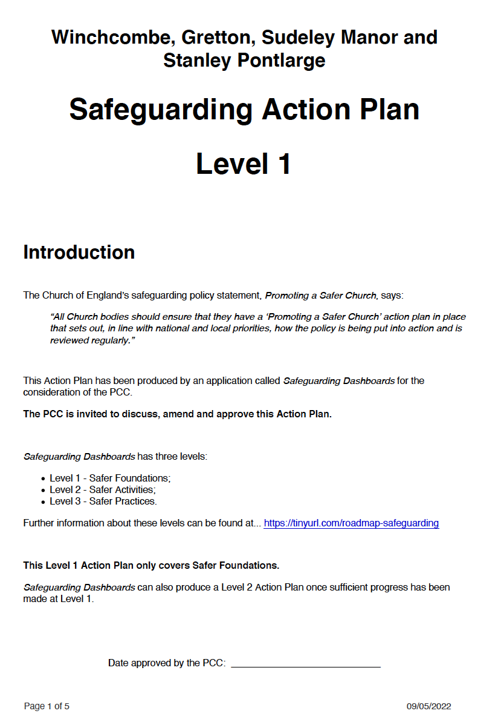

Please note that Page 2 of this document was blank and is not presented here.
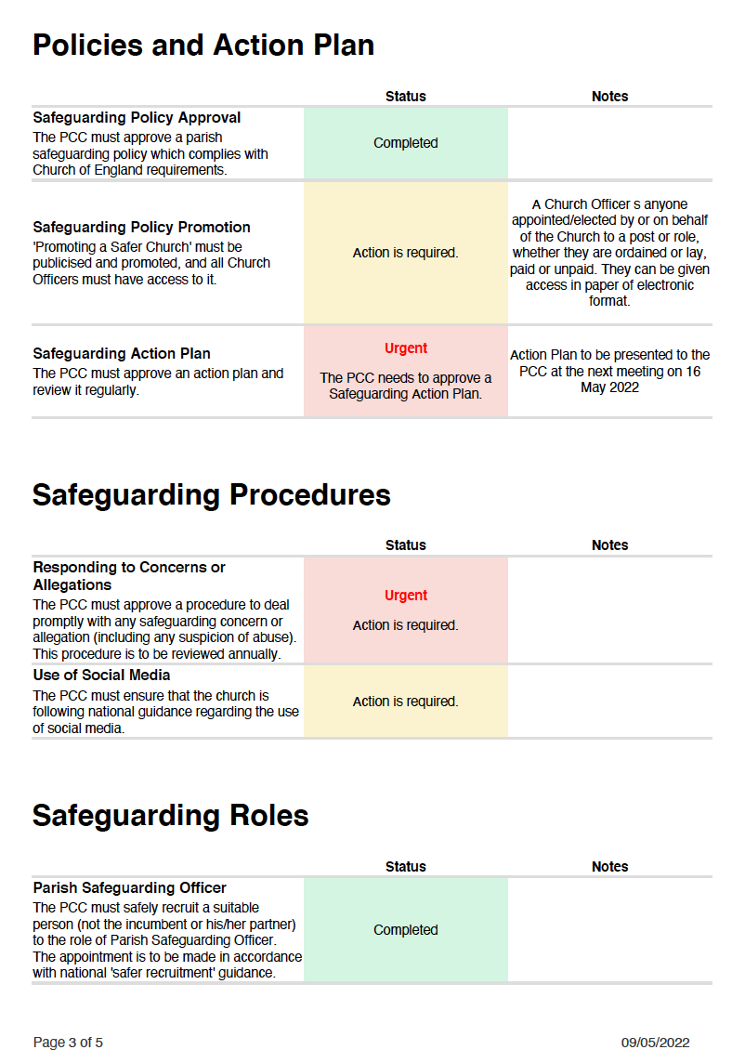

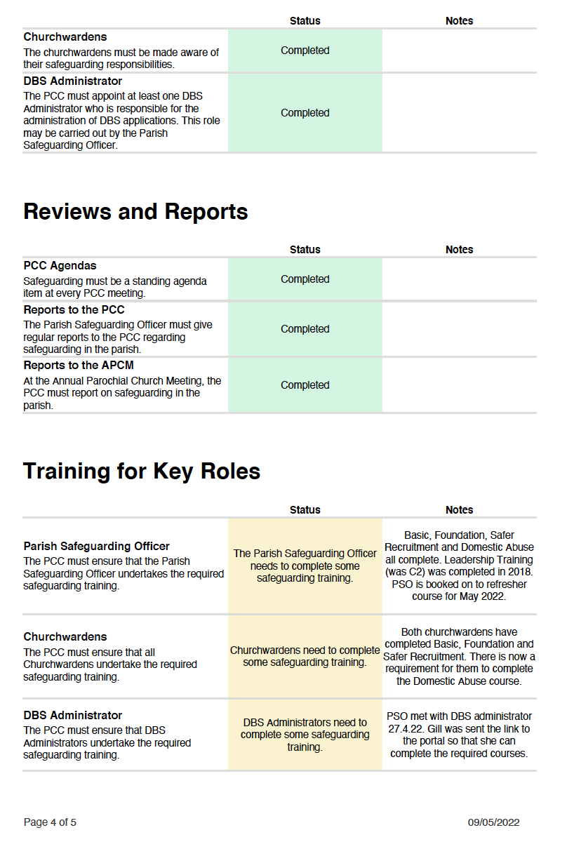

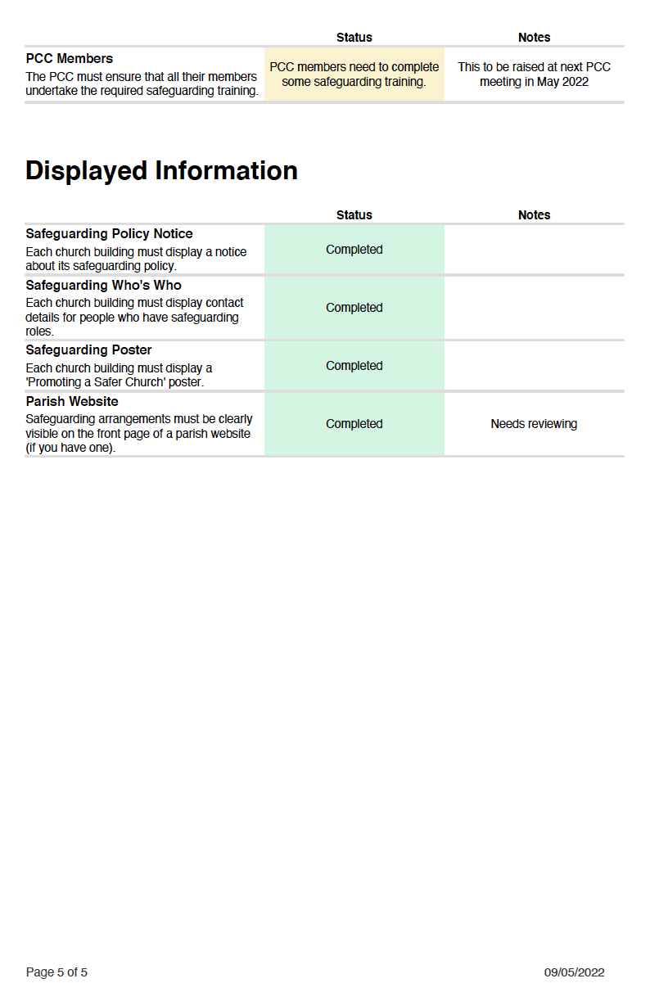

Attachment 4

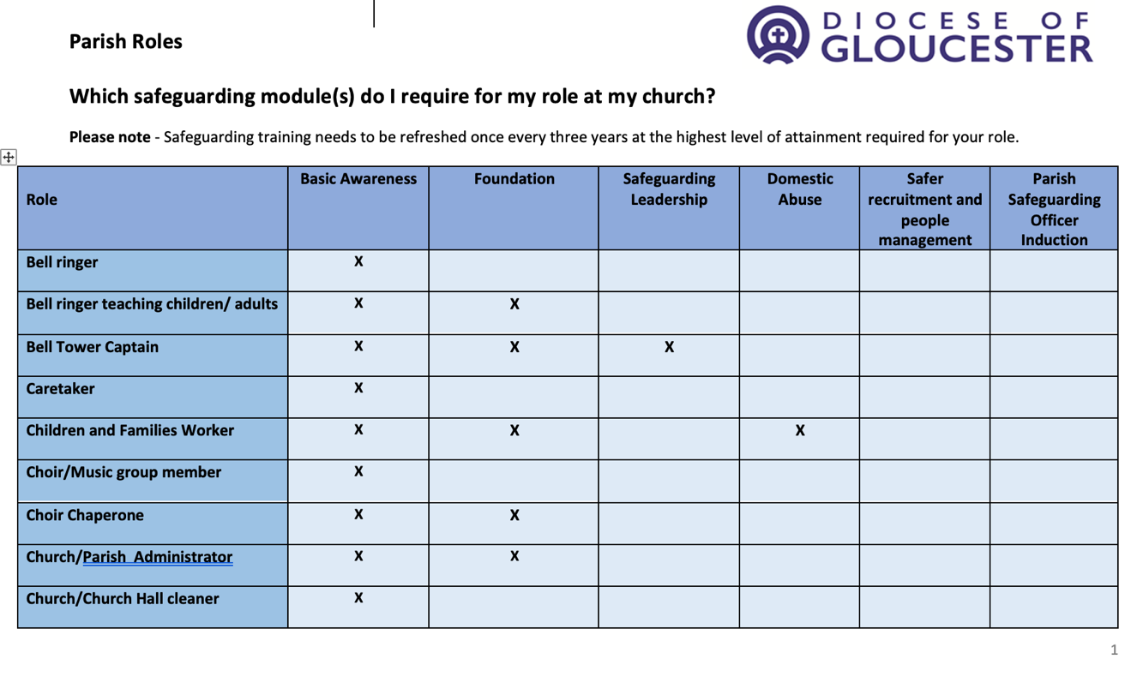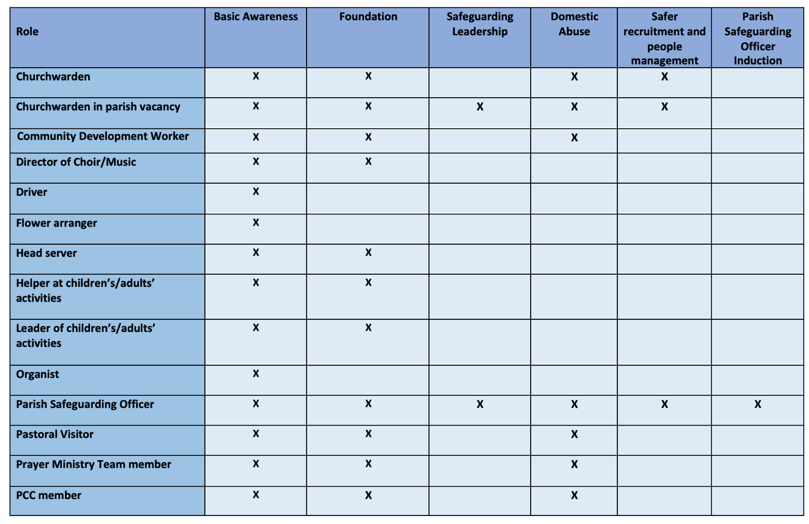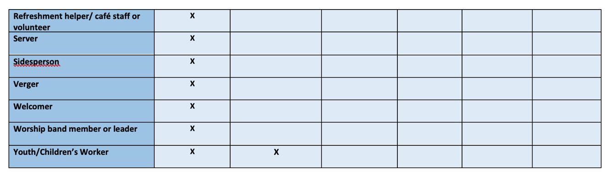

The Standing Committee consists of the Priest in Charge, the Churchwardens and at least two members of the PCC elected by that body.
Where a nominated person changes, the respective Group is to inform the PCC Treasurer.

