Winchcombe Parochial Church Council

Minutes of the Meeting held on 17th January 2022 at 7.30 pm

By Zoom
Present: Geof Adlington (GA) (Treasurer), Abbie Andrews (AA), Simon Andrews (SA) (Chair & Temp Sec), Elizabeth Atkinson (EA), Rob Davies (RD), Felicity King (FK), Judith Skinner (JS), Rob Stone (RS), Trevor Upton (TU) (Methodist Observer), Lizzy Watson (LW) Cathy Wilcock (CW), David Thomas (Parish Profile).
Apologies: Susan Fleck (SF), Tom Hancock (TH), Rosemary Hancock (RH), Rachel Murray (RM).
 |  | Action
1 | Welcome and Opening Prayer: JS said the opening prayers.
2 | Parish Profile Team Update: David Thomas made the following points:  Key Achievements:  • Profile Structure agreed by PCC.  • Google Drive technology platform established.  • Consultation plan completed and consultation process underway.  • Survey questionnaire developed and technology developed and tested.  • Communications plan in place and initial comms ready to go this week.  • Awaiting feedback from external stakeholders regarding the proposed layout.  Areas of concern:  • None at this stage.  Input required from PCC:  • Completion of Survey when you receive it (w/c 17 January).  • Written submissions if desired to ‘winchcombeppt@gmail.com’.  The PCC had no questions.
3 | Apologies for Absence: See above
4 | Matters Arising from Minutes of Meeting of 21 Sep 21:  - Teacher’s House funds allocation considerations group recommendations.  - Dates published for Julian of Norwich broadcast (RS).  - Magazine given point of contact for WCT (RS). | GA,RS, RD, JS  RS  RS
5 | Consideration of the agenda: Nil.
6 | Correspondence, News & Notices:  - Nil
7 | Coronavirus: Parish Activity Update: SA observed:  - Remains under continual review by Leadership Group.  - No significant changes from current systems.  - Receipt of Communion wine to be discussed under Item 12.
8 | Staffing & Appointments:  8.1 PCC Treasurer:  - A replacement remains needing serious attention to find candidates. PCC was asked at last meeting to explore the option of a paid Treasurer at this meeting. If there is no Treasurer, this would likely stop PCC activity.  - GA is still to speak to Roger Hargreaves as to whether he would consider the position although RS pointed out that this approach should be reconsidered.  - The hiring of a Treasurer was considered. GA noted this was likely not affordable given some 6hrs/wk = £240/wk. SA and JS would discuss separately. Afternote: RS offered the idea of seeking volunteers who do not receive a salary but might be attracted by an honorium of say £1000/yr.  8.2 PCC Secretary: Lizzie Watson has very kindly agreed to take this on for an initial period of one year under a mutual trial arrangement. A handover will be done between Simon Andrews, Lizzie and Sara Collins on Wed 26 Jan. | All  GA  JS/SA
9 | Finance:  - 2021 Accounts to date:  - GA circulated the figures and a report prior to the meeting. The meeting was too early to present the draft 2021 accounts. So, Attachment 1 is a spreadsheet of income and expenditure nominally to the end of 2021.  - Overall it was a difficult year financially but not unexpectedly so. The annual deficit of £14,885 is better than budget plan. The fall in church attendance/giving at church services is the big worry especially when coupled with the 9% drop in planned giving. Also noted was that due to the receipt of grants for future works and legacies received this year we did not have to draw down on our reserves to maintain cash flow through the year.  - 9.2 2022 Budget: The updated draft 2022 budget was presented reflecting the actual data for 2021, to incorporate new utility prices (having been forced to change supplier), a revision to the music budget to exclude wages of the Directors of Music (that is now in Wages and Salaries) and provided for the significant advertising costs associated with seeking a new priest-in-charge. GA concluded that in 2022 the PCC will incur an overspend of income similar to the 2021 budget and therefore be forced to draw down about £30,000 from the PCC’s investment accounts/reserves to maintain the required cash flow in 2022. However, the recent CCLA notification of some £10,000 increase in our reserves return will mitigate somewhat. It is expected that GA will present a budget for approval at the next meeting.  - 9.3 St Peter’s Energy Supplier: Gazprom supplies St Peter’s/SPC gas and has stated that our usage falls below our viability as a customer after our contract end in 2023. The Treasurer is seeking alternative options. We have already moved away from Gazprom for Parish electricity which is now supplied by EDF.  - 9.4 Insurance Renewal and Level for Teachers House: Insurance cover needed reviewing in the light of an increase premium owing to Teachers House being empty. PCC agreed that an all-risks cover policy was required. GA will continue his search for a suitable policy. Afternote: RS offered the Trinitas Church Insurance’s (www.trinitaschurchinsurance.co.uk) ParishCare policy as a potential one to look at.  - 9.5 Insurance for St Mary’s: After reviewing insurance levels with our current insurer (Ecclesiastical), the PCC approved the quoted premium (£1,854.32 for 50% cover with £250 excess). Should we transfer ownership of St Mary's to the Castle in the meantime, this should be refunded pro rata. GA was asked to action.  - 9.6 Fees for Funerals and Weddings, including Streaming:  - Local fees for life events such as weddings and funerals were reviewed and approved with some detailed uplifts.  - Increasing requests for on-line recordings of life events are anticipated. The PCC approved a fee of £75, with £40 going to the PCC, £25 to the organist as a performance fee, and £10 to the AV operator.  - An inflation related review would take place in Jan 23. | GA  GA  GA  EA
10 | Fabric/Churchwarden’s Update:  Read ahead notes were circulated prior to the meeting.  10.1: St Peter’s:  - On-line audio-visual (AV) provision of services: The camera is in and, after overcoming some initial teething issues, has been well received. RD and the contractor will do some additional work within the quote for allow audio to be synchronised with the on-line system. We await the confirmed final billing from the contractor; one parishioner has offered to cover any shortfall with a personal up to £250 contribution.  - Organ Repair. Nothing significant to report.  - West Glos St Wall Refurbishment. Winchcombe Town Council have elected not to fund the wall’s refurbishment next FY 22/23. SA has noted for re-engagement in Oct.  - Quinquennial Review. This was last done Dec 2017. SA will initiate with an architect this Summer.  10.2: Christ Church:  - Drainage investigation by Severn Trent Water: Investigative work has been re-programmed for 27 Jan.  10.3: St Michael’s:  - Restoration Update: SA re-engaged with the contractor and architect to start fixing work dates for the roofing work noting a wedding at St Michael’s on 28 Apr. The source quarry for the tiles is in the process of being leased to another company and so, whilst expected to be completed very soon, access to the tiles cannot yet be confirmed although our selected contractor expects to be the first to be supplied. The contractor is also aware of the time limit of offered grants (the nearest cut-off is 22 Jun 22 from GHCT) but is optimistic to be able to complete the job by Summer 22 and has offered work arounds if needed. Afternote: GHCT were warned and they are relaxed.  10.4: St Mary’s:  - Quinquennial Review:  - SA is close to fixing dates for stonework to be programmed.  - GA still seeks dates for downpipe repairs noting that Sudeley Castle re-opens to the public on 7 Mar.  - Future: On 20 Sep 21, JP, Alan Thomas and SA received initial feedback from Sudeley Castle via the Church Commissioners (ChCm) in the form of a proposed draft agreement between the Castle and PCC. In essence, there was little that was contentious within it as far as PCC reps were concerned and conformed pretty much with the draft agreement PCC reps had prepared in May 21 for the Castle’s comments. Whilst the PCC will receive a full brief from PCC reps/ChCm when progress is mature enough, the PCC approved the following in principle regarding the Castle’s Sep draft agreement:  - The Castle wishing to change the start time of the 6 services per year (1/month Apr-Sep) from the now 3.30pm, to 5pm. This allows them to have unrestricted access by the public to St Mary’s during the Castle’s normal working hours. The Castle would have to put in place a system to allow access/exit to parish worshippers after the Castle is closed to the public. PCC reps have asked the Castle to compromise with a 4 or 4.30pm service start but recommended that this does not become a red-line issue for the PCC if the Castle is insistent.  - In conjunction with a 5pm start time, the Castle putting in place an access route (see Attachment 2; yellow line) to St Mary’s that deconflicted with its public exit point.  - To hand over the whole of the current inventory to the Castle. This includes the BCP prayer and hymn books. As we have abundant of these within the Parish and it saves the admin burden of taking them over for a service.  10.5 Burial Ground Consecration: nothing significant to report.  10.6: Parish Churchyard Burial/Interment Policy: The only policy that exists is that issued by the Diocese and available on our church noticeboards. After discussions with St Peter’s and Christ Church’s representatives, the Diocese’s policy was considered sufficient. However, it was considered that St Michael’s had specific issues that the PCC approved in principle:  - Burial is restricted to those:  - Who have lived within the area of the old Stanley Pontlarge parish.  - Those who have a particular connection with the Saint Michael's Church, Stanley Pontlarge.  - NOTE: SA will confirm with the Diocese that limiting access for burial as described above is legal.  - Interments:  - A space is specified for cremation burials, and this area is identified on a precision internet map. It would be bounded by the specific geography of the churchyard, north of a line drawn due west from the NW corner of the church to the churchyard boundary. In order to avoid extant drains, its SE extremity would be marked by a ground level stud. Whether this is then formally assigned as a Garden of Remembrance with the need for a Faculty was left open.  - No burial and interment markers or memorial flowers etc would be allowed. Details of burial/interment locations would be via a marked map within the church supported by a digital map held by the Parish office.  - In future, burials/interments in the churchyard would have to be approved by the incumbent Priest-in-Charge, two Parish churchwardens, and the St Michael's Deputy Churchwarden with a majority decision required, and the incumbent having a casting vote in the case of no majority.  - These additional points raised will be forwarded to the interested parties with a view to presenting a final document for PCC approval.  10.7 Fabric Committee: Nothing significant to report.  10.8 Electronically Agreed Subjects Since Last Meeting:  - 15 Nov 21 PCC Meeting Minutes.  - Safeguarding Reporting Delegation.  - H&S Policy.  - Parish/Team Profile ToR Amendment including New Members.  - Eucharist Ministers’ Names.  - Parish/Team Profile Structure.  - Teachers House Survey Purchase. | SA  SA
11 | Vacancy: SA.  - JP remains officially our Priest-in-Charge until his instalment at Worcester Cathedral on 29 Jan.  - The programming of Parish-wide services and leads for them is in place up to Easter.  - At 2pm on Tue 15 Feb, there will be a brief to the PCC, retired clergy, Readers and the Parish Profile team about Team Ministry.
12 | Worship: JPH.  12.1 Home Communion Team:  - The Home Communion Team met on Wed 5 Jan and it was noted that everyone on the pre-Covid list plus one or two others received Holy Communion before Christmas.  - Penny Kain agreed to work out a new rota to start in early Feb meaning that all those on the list to receive Home Communion should be visited once a month.  - Anne Hand and JS joined the team and it was agreed that it would be good to meet as a team perhaps once every term. JS agreed to facilitate this meeting.  12.2 Wine at Communion: Bishop Rachel has recommended the dipping of the edge of the consecrated wafer into the chalice of wine (intinction) before putting it into the hands of each communicant which has become a standard way of receiving the sacrament in both kinds since the pandemic has raised serious concerns about sharing the common cup. The PCC approved the adoption of this method of giving communion across the Parish and JS will inform the clergy. St Peter’s will continue the system of the choir receiving communion at the altar and the congregation standing at the chancel step of our churches. The proposal that tables will be placed at each to hold the wine chalice for dipping is tbc. If people wish to receive the wafer only without intinction, they would indicate to the priest when they go up for communion. CW has agreed to undertake an investigation into the use of small receptacles/cups to offer individuals’ consecrated wine as an alternative method. | JS  JS  CW
13 | Children and Families  To date there has been no further action on the initiative to employ a youth worker but a meeting has been arranged for Tue 25 Jan at 2.30pm to determine how we can move forward with this project. It will be chaired by the Revd Michael Holloway and others attending will be Gemma Madell (WAM), Rob Stone and Judith Skinner.
14 | Pastoral Care Team  - The Pastoral Care Team met on Thu 6 Jan when JS distributed a simple manual which she had complied. It contained material on the qualities of a Pastoral Visitor plus 'dos & don'ts' when pastoral visiting and other information from the training day in Nov.  - As the team only numbers eight members it was decided, that as a general rule, only those at a point of need when a crisis or change of life situation had occurred would be contacted and asked if they would like a visit. It was acknowledged that already many members of the congregation already keep in touch with many of those who are now unable to attend services and this would be encouraged to continue.  - It was also acknowledge that there is an obvious synergy between the Home Communion Team and the Pastoral Care Team as those receiving Home Communion will have a regular monthly visit from a member of the church community. They would only be referred to the Pastoral Care Team if there was a sudden serious change in their circumstances.  - Lynne Banks is overseeing issues of safeguarding and confidentiality.  - A poster referring to the Pastoral Care Team will be displayed on the notice board at the back of the church and a mini version will go in the Parish Magazine.
15 | Diocesan and Deanery Synod Feedback  - No meeting since last PCC meeting.
16 | Winchcombe Churches Together (WCT):  - There is an issue regarding the availability of clergy to support WCT with the departure of JP and the only recent arrival of the new RC priest. Revd Mike Holloway has agreed to be a point of contact to the WCT clergy for specific questions. However, the projects WCT is overseeing are progressing well. RS has taken on the role of Acting Secretary in extremis.  - WAM/Medical Centre & Winchcombe Coordination Group. Its first meeting is delayed until 1 Feb. WCT involvement is uncertain.
17 | Teacher’s House:  - Having received an electronic version of the survey on Teacher's House it is clear that a substantial amount of money needs to be spent on it a rough estimate being £80-100,000.  - The greatest expenditure would be on insulating the roof which, because of the way it is constructed, would need to be removed and re-built with Cotswold stone tiles.  - Builder, Steve Arkell, and a damp specialist from Timberwise are both preparing estimates of the cost of the work necessary.  - When these are received Ben Moss of Adam's estate agents will recommend a new price with a view to re-market immediately.
18 | Safeguarding Update:  - The ‘Delegation of Serious Incidents’ form was sent to the Diocese and Lynne Banks has had confirmation that they have received and logged it.  - New Pastoral Team  - Gill Worthington is organising the DBS clearances for the 4 new members: Jill Hargreaves; Roger Hargreaves; Gaye Kimber; and Margaret Lloyd. Shelley Everall Hoban has a clearance for working with children so will need a new clearance for working with adults at risk. The clearance for Lynne Banks is due for renewal. Lesley Davies and Jude Skinner both have appropriate up to date clearances.  - We are following the Safer Recruitment process for those members of the new Pastoral Team who have not previously held a voluntary position within the church working with vulnerable groups.  - Lynne has received an email from the Safeguarding Team at the Diocese that there is a new ‘Safeguarding Learning and Development Framework - Church of England’ that all dioceses, cathedrals, churches and PCCs are required to implement. She is planning to attend a Zoom Safeguarding Workshop, run by the Diocese, on 27 Jan when and will feedback to the PCC.
19 | Magazine:  - Contributors will be asked to take care in their articles as some presented have been too ‘wordy’ given the space available. Additionally, they will be reminded that the readership is wider than the attending Parish congregations and therefore, terminology used in articles should be understandable to all.
20 | Eco Group:  - 2 rowan trees have been planted in St Peter’s churchyard flanking the pathway to the North gate..  - Heating of Parish Buildings:  - RS has kindly agreed to be the PCC’s focus regarding the boiler, heating, lighting research project, specifically for St Peter’s but with relevance to our other buildings.  - He is looking at options at other locations that best reflect St Peter’s situation and size. | RS
21 | Events:  21.1: Son-et-Lumière has been postponed to Autumn 22. RD has been asked to propose a date. RD further noted that St Peter’s has no hospitality focus, particularly after the departure of Liz Hoskins, making the requesting of event catering support challenging. RD asked that ideas for future events should be forwarded to him to populate an events matrix.  21.1.1: RD asked if consideration might be given to putting back the date of the parish fête to take advantage of a new vicar being in post. SA observed that there was no guarantee that a new vicar would be in place by then and the advertising horse had already left the stable so the 2 Jul was fixed.  21.2: HM Big Jubilee Lunch (5 Jun 22). Winchcombe Town Council (WTC) are aware that various groups within the town are likely to organise their own street parties, in a similar way to the Queen’s Silver Jubilee. Therefore, the Council will not be organising any special event. The gov.uk web site has guidance on how to organise a street party and WTC will provide support where possible. The Parish will not organise a separate event so parishioners should look to their own streets. RS (via WCT) will inform other churches of this for information. To note, Mill Lane residents (via Philip Barton) have asked for 6 x folding tables from St Peter’s which has been agreed.  20.3 Winchcombe Festival of Music and Arts (WFMA) 2022. WFMA has confirmed they are doing the event over a 4-day event in mid-Sep 22. St Peter’s remains ready to support as a venue.  21.4 St George’s School, Windsor Choral Concert (12 Feb). The school's Chamber Choir will be performing a short concert on Sat 12 Feb at 3pm in St Peter's church. Our concert secretary, Martin Gorman, is liaising with James Wilkinson from St George's School, Windsor and has everything in hand for this event. | RD  All  RS
22 | Business from:
19.1 St Peter’s, Winchcombe: Nil.
19.2 Christ Church, Gretton:
- The litter dumping continues and advice has been sought from Tewkesbury BC Environment Department.
19.3 St Michael’s, Stanley Pontlarge:
- Monthly services have continued and have been generally well attended with around 15-18 people present.
- The Carol Service took place on 17 Dec. Beautifully decorated and well attended with after service mulled wine and mince pies served outside around a firepit.
- The Christmas Day service was very well attended. For both the Carol Service and the Christmas Day service, a booking system was set up by Gill Badger and Mark Mulley to ensure that sufficient distance could be maintained between household ‘bubbles’. The system worked well in the main although some people did turn up to Christmas Day without booking. Happily the newcomers could be accommodated, although it is understood that one person had to sit on the organ stool (there was no organist that day!)

19.4 St Mary’s, Sudeley: Nothing significant to report.

19.5 Steward’s Report: Lynn Gorman reported that she did not have actual visitor numbers but they were increasing in Nov/Dec. The lack of full Steward cover means visitors are not always being recorded. The credit card machine remains ‘unpredictable’.

23 | Any other Business:  - SA raised the following:  - Book Fair: currently programmed from 13 Jun-2 Jul but, with Open Gardens announced for 12 Jun, the Book Fair will now start 1 week earlier on Mon 6 Jun) but still end on the fête on 2 Jul.  - Tewkesbury Tourist Info Office (TIC): whilst related to Winchcombe’s own TIC, advertisers for local events should also consider using Tewkesbury’s via (Rachel.Thatcher@tewkesbury.gov.uk).  - SPC Plastic Chairs/Tables Replacement: Jane Wain has accepted a donation of £100 from Brockhampton Quilters in memory of Joan Holgate to source replacement adult furniture for the SPC garden.  - Utilities Contracts: after some confusing conversations with Gazprom over contract renewals and future changes in service provision, SA asked GA for details of our utility providers and the contract renewal dates to expand the collective knowledge base.  - Operation LONDON BRIDGE (relating to the death of HM The Queen): in discussion with the Town Council, they will notify through their systems that a Book of Remembrance (in St Peter’s South aisle outside the Lady Chapel) and an area to lay flowers in St Peter’s churchyard will be made available to the general public. The PCC agreed to site the flower area in the SW of the churchyard delineated by the churchyard drive from Gloucester St and pedestrian path from St Peter’s to SPC. Roping/signs would be used to ensure that flowers are first laid against the boundary wall. The ropes/signs will be progressively moved Eastward as the delineated area filled.  - RS’s query regarding hiring a Treasurer is reported under Item 8.1. | GA  SA
24 | Dates of Future PCC Meetings: 14 Mar; 16 May; 18 Jul; 19 Sep; 14 Nov. All at 7.30pm. Venue tbc.
25 | The meeting closed at 9.30pm with All saying the Grace.
Approved: _______________________________________________Date: ____________________

Attachment:
1. PCC Draft End of Year Forecast.
2. Sudeley Castle Proposed Right of Way to St Mary’s.
3. 1900 Stanley Pontlarge Parish Boundary Map.

Attachment 1
Code | Description | Unrestricted | Budget for year | 2022 Budget proposal
 |  | £ | £
1 | Total planned giving | 64306 | 68,367 | 68,000
3 | Other collections at services | 4157 | 9,500 | 5,000
5 | Other Giving & Donations - Non-Recurring | 7455 | 6,000 | 8,000
6 | Special Appeals | 2,858 | 0 | 0
7 | Gift Aid Tax receipts under direct Stewardship | 18,353 | 17,700 | 17,500
8 | Legacies received | 12,700 |  | 0
10 | Non-Recurring Grants | 28,000 | 250 | 250
11 | Fund Raising Events | 8,399 | 3,500 | 5,000
12 | Dividends & Interest | 3,033 | 2,500 | 10,000
13 | Income from Properties | 8,310 | 12,000 | 3,600
14 | Net Parochial Fees Income | 6,873 | 10,000 | 10,000
15 | Bookstall, Magazine etc | 6,388 | 4,400 | 6,000
17 | Income from other Church Activities | 20 | 100 | 100
19 | Reimbursement of costs by other Parishes | 0 | 500 | 0
22 | Other Income | 4,788 | 4,250 | 4,500
 | Total Income | £175,640 | £139,067 | 137,950
30 | Fund Raising Costs | -509 | -235 | -400
31 | Donations/Grants to Charities & Mission Giving | -2,830 | -2,400 | -5,000
32 | Parish Share | -78900 | -78,900 | -83,634
33 | Salaries & Wages | -8,016 | -10,000 | -8,400
34, 35 & 36 | Clergy and Other Expenses | -1,751 | -2,370 | -1,500
37 | Local Mission and Evangelism Projects | -809 | -325 | -400
38 | Children/Youth Work costs | -552 | -890 | -800
39 | Insurance costs | -11,473 | -11,865 | -11,500
40 | Cleaning costs | -991 | -1,100 | -1,000
41 | Minor Repairs/Routine Maintenance | -8,621 | -3,000 | -3,000
42 | Administration costs | -4,478 | -2,500 | -2,500
43 | Other Church Expenses/Provision of Services | -1,611 | -1,750 | -2,000
44 | Churchyard Maintenance | -1,418 | -1,500 | -1,600
45 | Flowers | -243 | -200 | -200
46 | Music costs | -8,175 | -9,700 | -2,500
47 & 48 | Utilities (incl Heat, Light and Water) | -3,831 | -8,500 | -10,000
49 | Costs of Trading | -4,734 | -4,650 | -4,750
58 | Sundry Expenses | -4,548 | -2,250 | -500
59 | Major Repairs/Redecoration to Church Building | -11,548 | -9,000 | -12,569
60 | Major Repairs/Redecoration to other properties | -1,043 | -500 | 0
61 | Other major repairs/expenses | -1,831 | -5,000 | -2,000
 | Total Expenses | -£157,911 | -£156,635 | -154,253
 | Net Surplus/-Deficit to date | £17,729 | -£17,568 | -16,303
 | Unused Grants for Stanley P works | -£25,714
 | Unused legacy designated for ST P organ | -£6,665 |  | 0
 | Actual surplus/ deficit to EoY | -14,650 | -17,568 | -16,303
 | Budgeted Deficit for 12 months to 31 December 2021 |  | -£17,568

Attachment 2

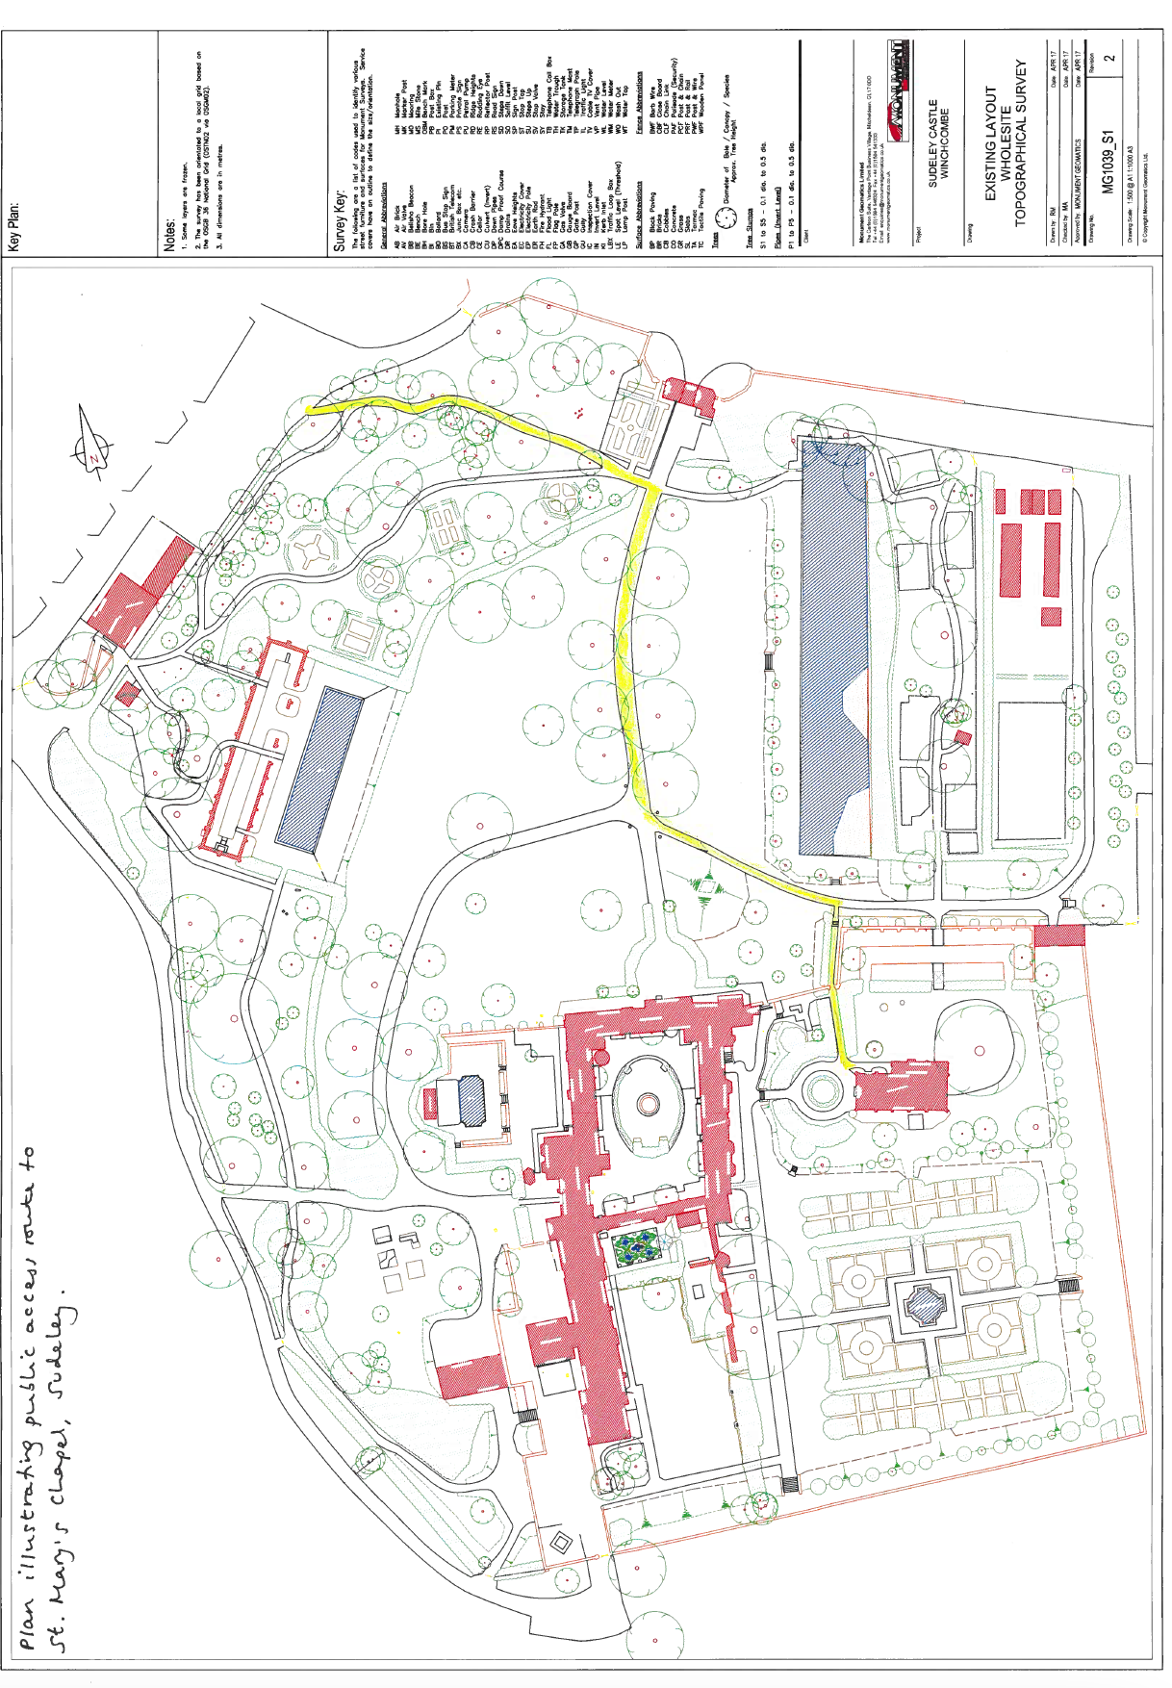

Attachment 3

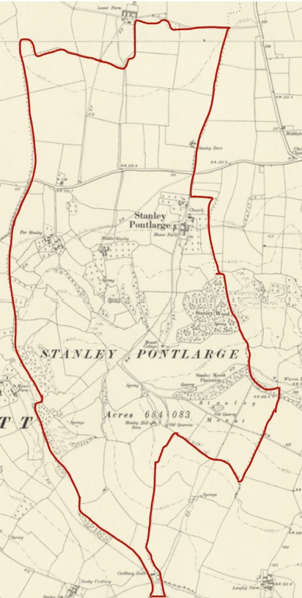

As defined in the map at Attachment 3 showing the boundaries of the old Parish of Stanley Pontlarge at 1900. It is derived from the Gloucestershire Sheet XX.NW and from Gloucestershire Sheet XIII.SW (both revised 1900 and published 1903). These maps are available at National Library of Scotland.

